# **Restaurant & User App Requirements**

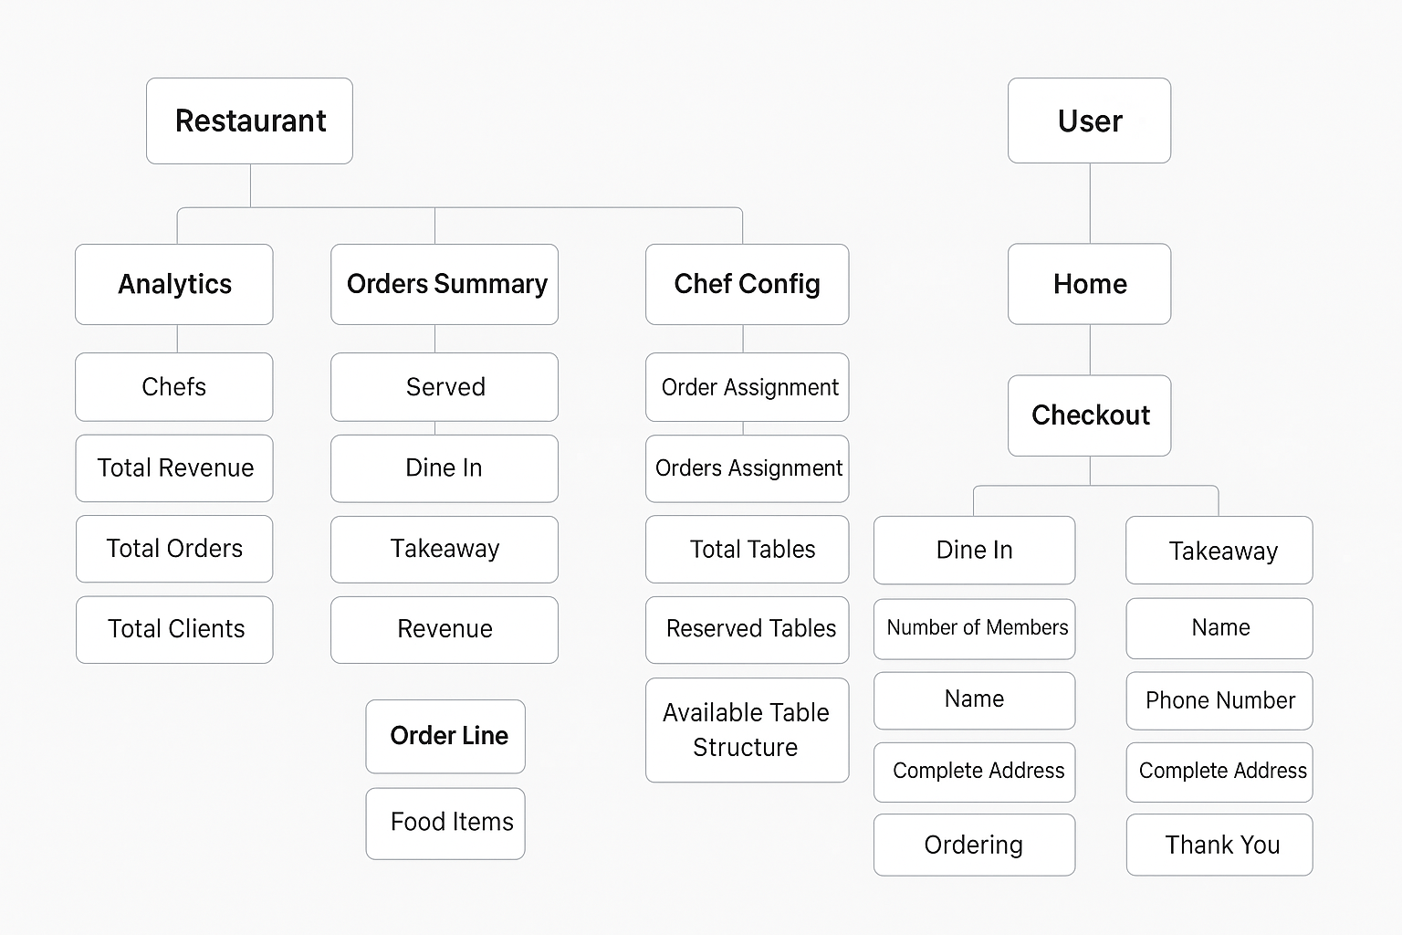

## **Restaurant Section**

**Access:**

* No login or signup; directly opens dashboard at /.

**Header:**

* Company logo on the left of the filter (any logo).
* Search filter: blurs the rest of the container except the searched item.

**Features:**

* Drag & Drop functionality (custom logic).

### **Analytics Section**

* **Chefs:** 4
* **Total Revenue:** Revenue from all orders till date
* **Total Orders:** All orders till date
* **Total Clients:** Unique clients based on phone number

### **Orders Summary**

**Filters:** Daily, Weekly, Monthly

**Metrics:**

* **Served:** Orders served to tables
* **Dine In:** Total dine-in orders
* **Takeaway:** Total takeaway orders
* **Revenue**

**Graph Options:** Daily, Weekly, Monthly, Yearly

**Tables View:**

* Green: Reserved table
* White: Unreserved table

### **Chef Configuration**

* **Order Assignment:** Random if chefs have same number of orders
* **Orders Assignment:** Assign to chef with fewer orders

### **Tables Section**

* **Total Tables:** 30
* Reserved tables cannot be deleted
* Tables should be booked based on number of persons
* Deleting a table reshuffles table numbering (always sequential: 1, 2, 3…)
* Available table sizes: 2, 4, 6, 8
* Table name is optional

### **Order Line**

* **Order ID:** Unique; cannot be duplicate
* **Dine In Orders:** Show table number
* **Takeaway Orders:** Show takeaway
* **Number of Items:** Total items in the order
* **Processing Time:** Countdown decreases on refresh, not real-time
* **Order Done:** Automatic when processing ends

### **Menu Management**

Each menu item includes:

{

"name": "",

"description": "",

"price": "",

"averagePreparationTime": "",

"category": "",

"stock": ""

}

## **User Section**

### **Home Page**

* Lands directly at /
* Shows available categories; default selected category shows all items
* Multiple categories; horizontally scrollable
* Search applies to the selected category only
* Infinite loading for items in a category
* Users can add or remove items

### **Checkout Page**

* No search
* Users can add cooking instructions
* Switch between **Dine In** and **Takeaway**

**Dine In:**

* Number of members
* Name
* Phone Number

**Takeaway:**

* Name
* Phone Number
* Complete Address
* Show average delivery time

**Ordering:**

* Swipe to order (no click)
* Show a “Thank You” page for 2 seconds before redirecting to /